Coplanarity

Definition
# Source: AI Source: Provided by: [Data Path: Persons Table -> ID Column: 1, Name_En Column: Motasem Essam] -> From: [ChatGPT] on [7/25/2026]
Coplanarity is a geometric relationship in which two or more geometric objects lie in the same plane.
A plane is a flat, two-dimensional surface that extends infinitely in all directions.
For example, if points $A$, $B$, $C$, and $D$all lie in plane $α$, then they are coplanar:
$$A,B,C,D∈α$$
If no single plane contains all the objects under consideration, they are non-coplanar.
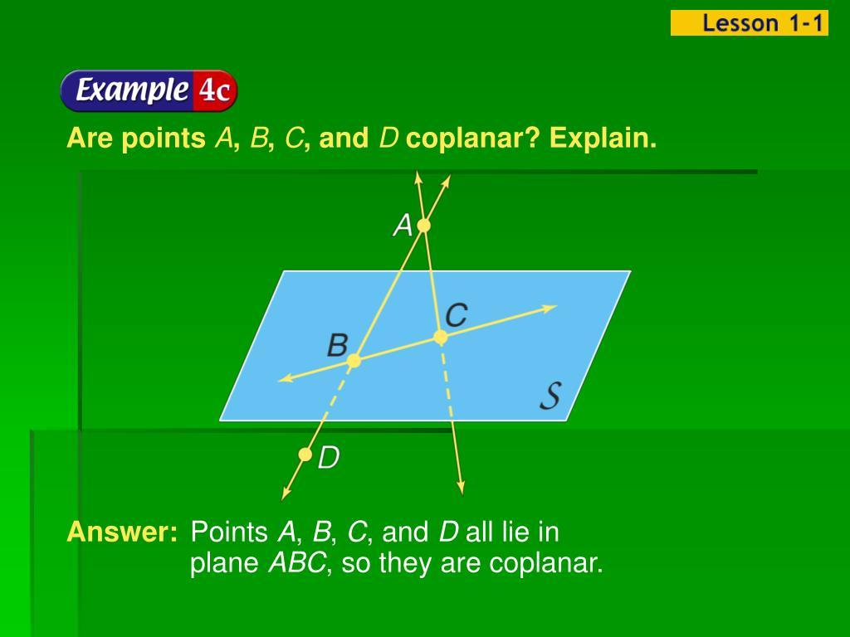
Add to Favorites
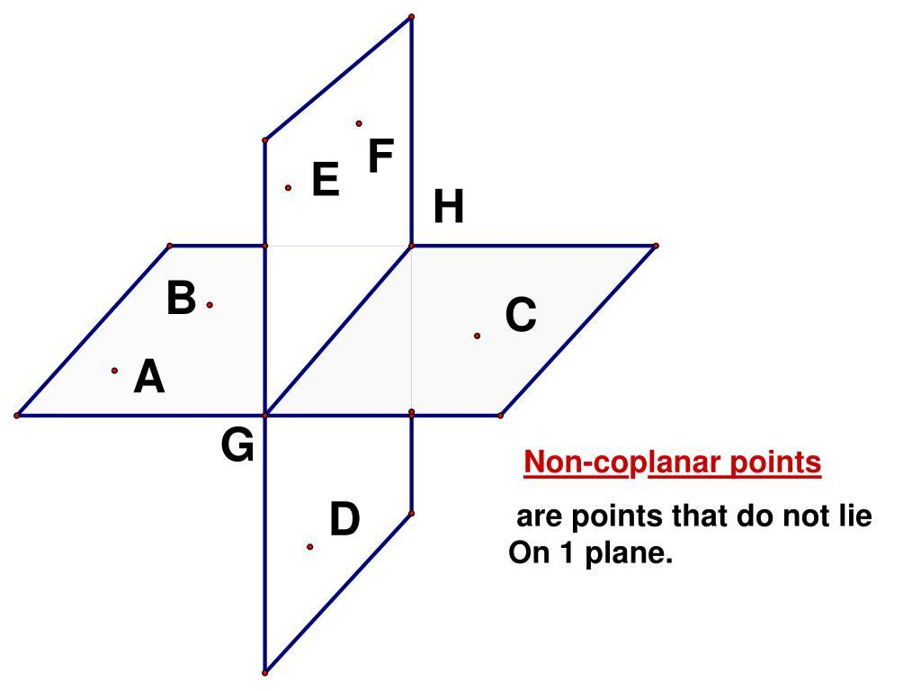
Add to Favorites
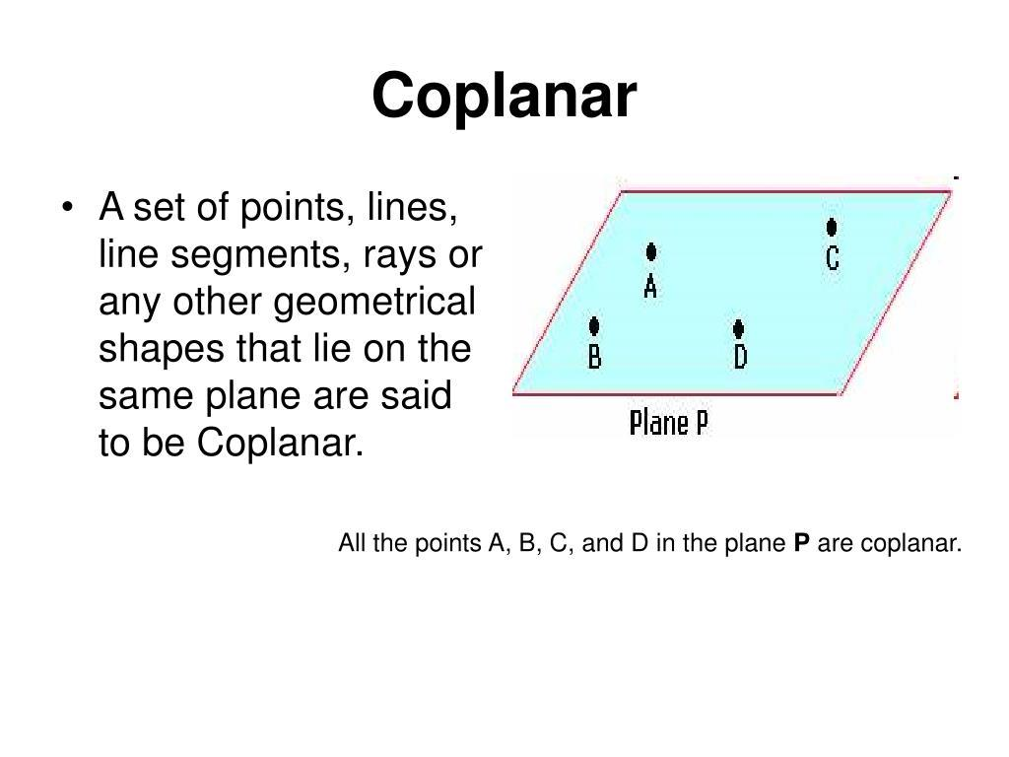
6
Add to Favorites

Purpose
# Source: AI Source: Provided by: [Data Path: Persons Table -> ID Column: 1, Name_En Column: Motasem Essam] -> From: [ChatGPT] on [7/25/2026]
Coplanarity is used to:
- Determine whether geometric objects lie in the same plane.
- Describe the spatial arrangement of points, lines, and other geometric objects.
- Distinguish plane geometry from three-dimensional geometry.
- Analyze intersections between lines and planes.
- Establish geometric constructions and proofs.
- Study polygons, polyhedra, and spatial relationships.

Fundamental Concept
# Source: AI Source: Provided by: [Data Path: Persons Table -> ID Column: 1, Name_En Column: Motasem Essam] -> From: [ChatGPT] on [7/25/2026]
The central idea is:
Coplanar objects share one common plane.
For points $A,B,C,D$, coplanarity means there exists a plane $α$such that
$$A,B,C,D∈α$$
For example, four points at the corners of a rectangle are coplanar because the rectangle lies entirely in one plane.
However, four points in three-dimensional space are not necessarily coplanar.

Types of Coplanarity
# Source: AI Source: Provided by: [Data Path: Persons Table -> ID Column: 1, Name_En Column: Motasem Essam] -> From: [ChatGPT] on [7/25/2026]
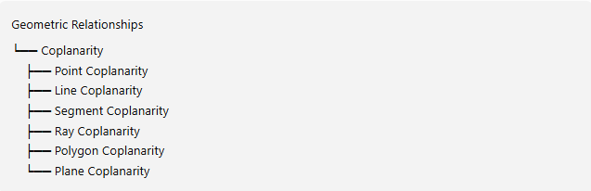
Geometric Relationships
└── Coplanarity
├── Point Coplanarity
├── Line Coplanarity
├── Segment Coplanarity
├── Ray Coplanarity
├── Polygon Coplanarity
└── Plane Coplanarity
These are useful categories based on the types of objects being considered, rather than an exhaustive formal classification.

1. Point Coplanarity
# Source: AI Source: Provided by: [Data Path: Persons Table -> ID Column: 1, Name_En Column: Motasem Essam] -> From: [ChatGPT] on [7/25/2026]
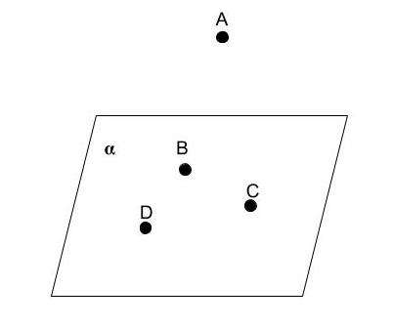
Points are coplanar when they all lie in one plane.
Example:
$$A,B,C,D∈α$$
Important property: Any three points are coplanar. Four or more points may or may not be coplanar.

2. Line Coplanarity
# Source: AI Source: Provided by: [Data Path: Persons Table -> ID Column: 1, Name_En Column: Motasem Essam] -> From: [ChatGPT] on [7/25/2026]
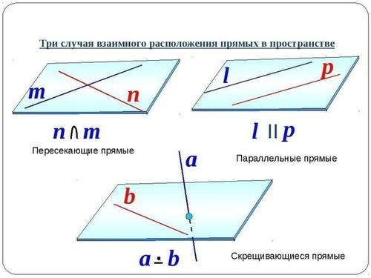
Two or more lines are coplanar when they all lie in the same plane.
Two distinct lines in three-dimensional Euclidean space are coplanar if they intersect or are parallel. If they neither intersect nor are parallel, they are skew lines, which are non-coplanar.

3. Segment Coplanarity
# Source: AI Source: Provided by: [Data Path: Persons Table -> ID Column: 1, Name_En Column: Motasem Essam] -> From: [ChatGPT] on [7/25/2026]
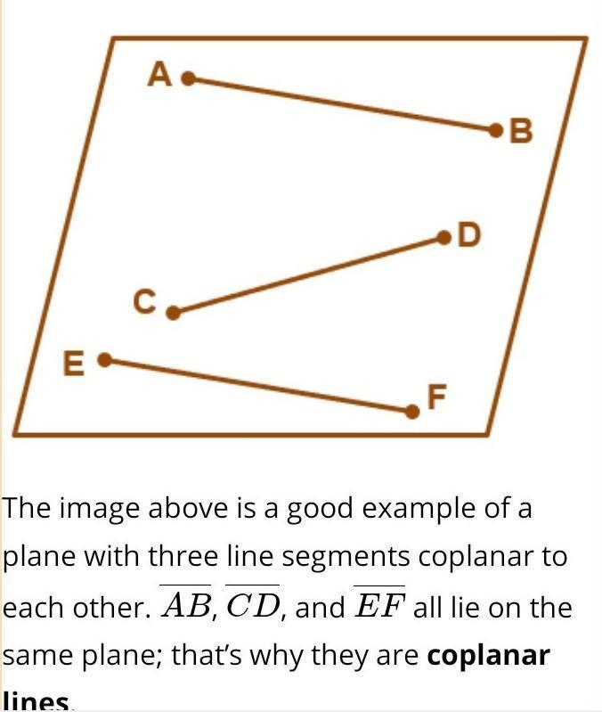
Two or more line segments are coplanar if they lie in the same plane.
For example, all four sides of a rectangle are coplanar because they belong to the same plane.
$$\overset{‾}{AB},\overset{‾}{BC},\overset{‾}{CD},\overset{‾}{DA}⊂α$$

4. Ray Coplanarity
# Source: AI Source: Provided by: [Data Path: Persons Table -> ID Column: 1, Name_En Column: Motasem Essam] -> From: [ChatGPT] on [7/25/2026]
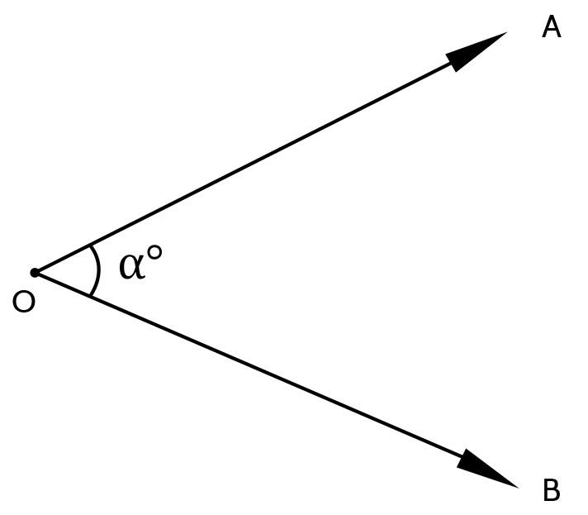
Two or more rays are coplanar if every ray lies entirely in one common plane.
For example, two rays forming an angle are coplanar because both lie in the plane containing that angle.

5. Polygon Coplanarity
# Source: AI Source: Provided by: [Data Path: Persons Table -> ID Column: 1, Name_En Column: Motasem Essam] -> From: [ChatGPT] on [7/25/2026]
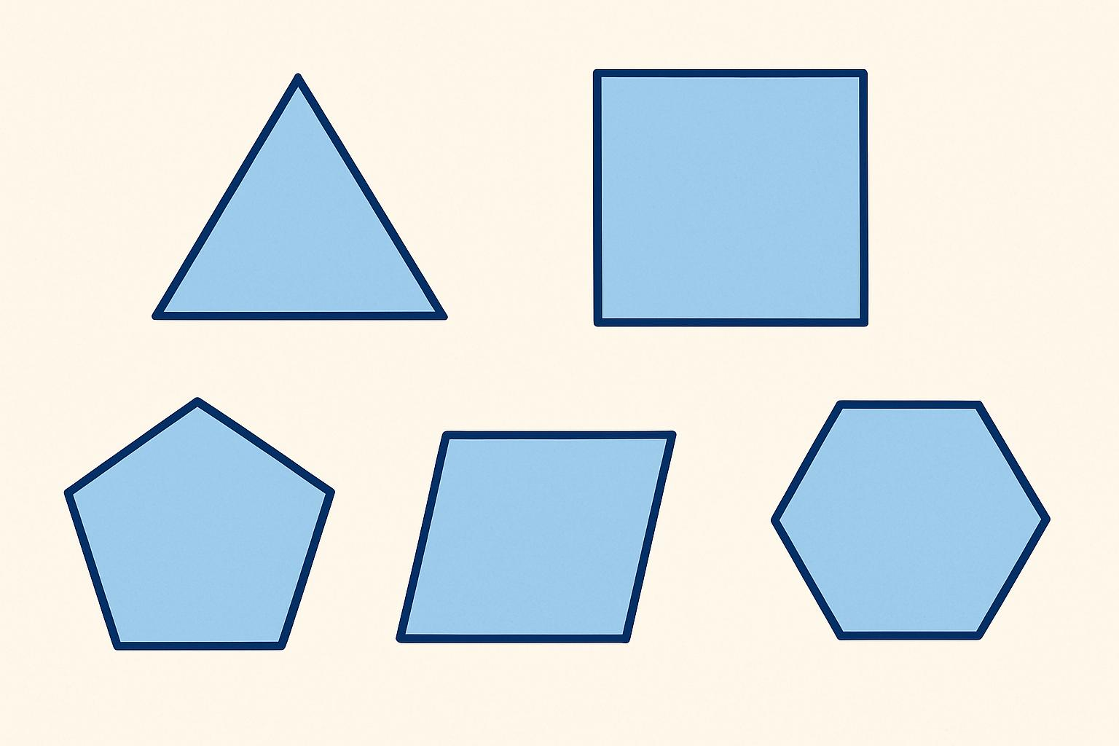
A polygon is a plane figure, so all its vertices and sides lie in one plane.
Examples include:
- Triangles
- Squares
- Rectangles
- Pentagons
- Hexagons
A polygon's vertices are necessarily coplanar. By contrast, the vertices of a three-dimensional polyhedron are not necessarily all coplanar.

6. Plane Coplanarity
# Source: AI Source: Provided by: [Data Path: Persons Table -> ID Column: 1, Name_En Column: Motasem Essam] -> From: [ChatGPT] on [7/25/2026]
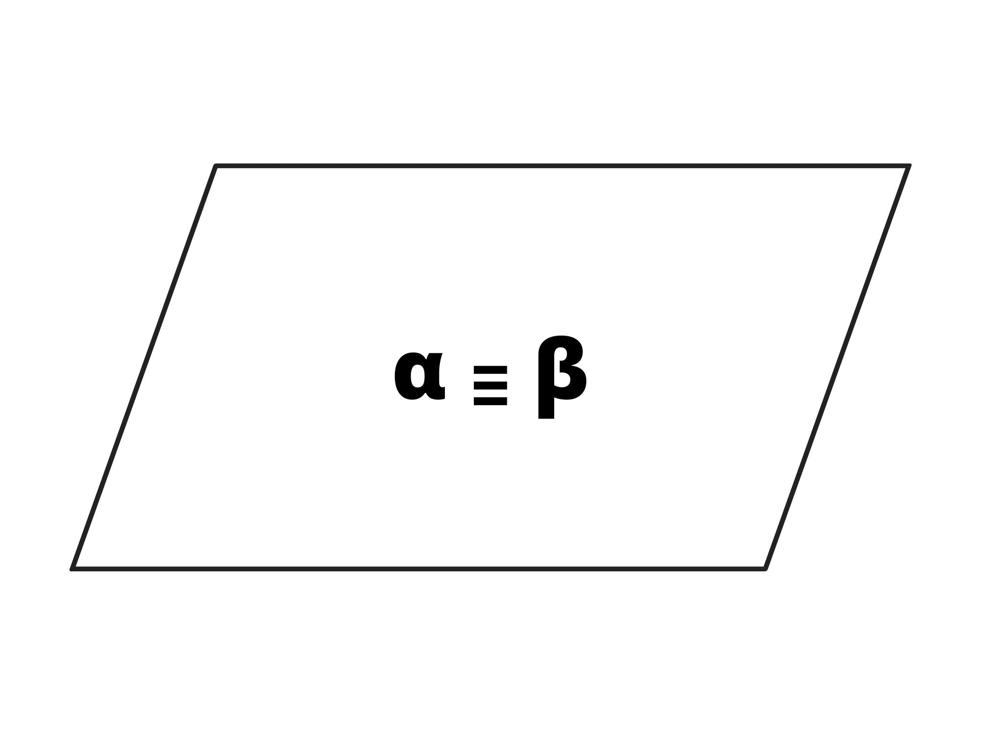
Two or more planes are coplanar in the sense that they occupy the same plane only when they are coincident. Distinct planes in three-dimensional space are not all contained in one single plane.
This differs from lines: distinct intersecting or parallel lines can belong to one common plane.

Mathematical Tests for Coplanarity

1. Geometric Test
# Source: AI Source: Provided by: [Data Path: Persons Table -> ID Column: 1, Name_En Column: Motasem Essam] -> From: [ChatGPT] on [7/25/2026]
Determine whether a single plane contains all the objects.
- If one plane contains all the objects, they are coplanar.
- If no single plane contains them, they are non-coplanar.

2. Coordinate Test for Four Points
# Source: AI Source: Provided by: [Data Path: Persons Table -> ID Column: 1, Name_En Column: Motasem Essam] -> From: [ChatGPT] on [7/25/2026]
Suppose four points in three-dimensional space are
$$A\left(x_{1} , y_{1} , z_{1}\right), B\left(x_{2} , y_{2} , z_{2}\right), C\left(x_{3} , y_{3} , z_{3}\right), D\left(x_{4} , y_{4} , z_{4}\right)$$
The four points are coplanar if the scalar triple product is zero:
$$\boxed{∣\begin{matrix}x_{2}-x_{1} & y_{2}-y_{1} & z_{2}-z_{1} \\ x_{3}-x_{1} & y_{3}-y_{1} & z_{3}-z_{1} \\ x_{4}-x_{1} & y_{4}-y_{1} & z_{4}-z_{1}\end{matrix}∣=0}$$
This condition means the signed volume of the tetrahedron formed by the four points is zero.
Example
Consider the points
$$A\left(0 , 0 , 0\right), B\left(1 , 0 , 0\right), C\left(0 , 1 , 0\right), D\left(1 , 1 , 0\right)$$
All four points have $z=0$, so they lie in the plane
$$z=0$$
Therefore, the four points are coplanar.
In contrast, if $D=\left(1 , 1 , 1\right)$, the four points are non-coplanar because the determinant is nonzero.

Coplanarity vs. Non-Coplanarity
# Source: AI Source: Provided by: [Data Path: Persons Table -> ID Column: 1, Name_En Column: Motasem Essam] -> From: [ChatGPT] on [7/25/2026]

Relationship | Condition
Coplanarity | All objects lie in one common plane
Non-coplanarity | No single plane contains all the objects

Coplanarity vs. Related Geometric Relationships
# Source: AI Source: Provided by: [Data Path: Persons Table -> ID Column: 1, Name_En Column: Motasem Essam] -> From: [ChatGPT] on [7/25/2026]
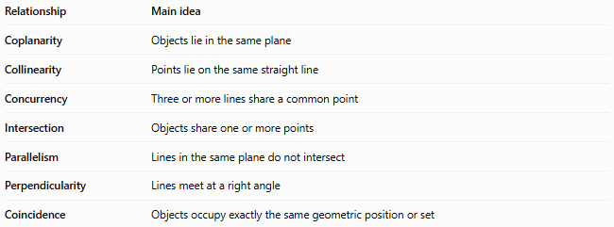
Relationship | Main idea
Coplanarity | Objects lie in the same plane
Collinearity | Points lie on the same straight line
Concurrency | Three or more lines share a common point
Intersection | Objects share one or more points
Parallelism | Lines in the same plane do not intersect
Perpendicularity | Lines meet at a right angle
Coincidence | Objects occupy exactly the same geometric position or set
Important distinction: Collinearity concerns one straight line, while coplanarity concerns one plane. All collinear points are coplanar, but coplanar points do not necessarily lie on one straight line.

Important Properties
# Source: AI Source: Provided by: [Data Path: Persons Table -> ID Column: 1, Name_En Column: Motasem Essam] -> From: [ChatGPT] on [7/25/2026]
- Any three points are coplanar.
- Four points may be coplanar or non-coplanar.
- Two intersecting lines are coplanar.
- Two parallel lines are coplanar in Euclidean space.
- Skew lines are non-coplanar.
- Every polygon is planar, so its vertices are coplanar.
- Four non-coplanar points determine a tetrahedron with nonzero volume.
- Coplanarity is a fundamental concept in three-dimensional geometry.

Key Points
# Source: AI Source: Provided by: [Data Path: Persons Table -> ID Column: 1, Name_En Column: Motasem Essam] -> From: [ChatGPT] on [7/25/2026]
- Coplanarity = lying in the same plane.
- Coplanar objects share one common plane.
- Non-coplanar objects cannot all be contained in one plane.
- The determinant test can determine whether four points in three-dimensional space are coplanar.
- Coplanarity differs from collinearity and concurrency.

Conclusion
# Source: AI Source: Provided by: [Data Path: Persons Table -> ID Column: 1, Name_En Column: Motasem Essam] -> From: [ChatGPT] on [7/25/2026]
Coplanarity describes whether points, lines, segments, rays, or other geometric objects lie in a common plane. It is essential for understanding spatial arrangements, three-dimensional geometry, and the relationships between lines and planes.

